Multi-Algorithm Recommendation System Comparison
E-Commerce Customer Behavior Analysis using Regression, Classification & ClusteringE-Commerce Customer Behavior Analysis using Regression, Classification & Clustering
Mini Project 3 — Mentor-Validated Deliverable

1. Problem Statement
E-commerce businesses need to understand three related but distinct questions about their customers: how much value will a customer generate, how likely are they to respond to marketing efforts, and what natural groups do customers fall into based on behavior. This project builds and compares three machine learning approaches — regression, classification, and clustering — to answer each question, and evaluates which technique is most useful for which business decision.

2. Dataset Description
The dataset used is "ecommerce_user_segmentation.csv", containing 10,000 customers and 14 columns of RFM (Recency-Frequency-Monetary) and engagement behavior data.

2.1 Adaptation Note
The original project template assumes an interaction-level dataset (one row per user-product pair) with explicit Rating and Purchase Status columns. The available dataset is customer-level instead — one row per customer with behavioral summary metrics — and does not contain a Rating or Purchase Status column. The three ML tasks were therefore adapted to fit the real data while keeping the exact same algorithms, tuning process, and metrics required by the assignment:
ML Task | Original Template Target | Adapted Target (this dataset) | Reason
Regression | Rating | Monetary (total customer value) | No rating column exists; Monetary is the closest continuous business-value target
Classification | Purchase Status | Campaign_Response (0/1) | No purchase flag exists; Campaign_Response is the dataset's only binary outcome
Clustering | Customer segments | Customer segments (unchanged) | Dataset already suits this task directly

2.2 Columns Used
Behavioral features used across all three models: Recency, Frequency, Avg_Order_Value, Session_Count, Avg_Session_Duration, Pages_Viewed, Clicks, Wishlist_Adds, Cart_Abandon_Rate, Returns.
Customer_ID is an identifier and was excluded from modeling. Segment_Label is a pre-existing categorical tier (Iron/Copper/Silver/Gold/Platinum) retained only to validate the clustering results, not used as an input feature.

3. Data Preprocessing
- Missing values found: 0 (none) — no imputation needed.
- Duplicate records found: 0 (none) — no removal needed.
- All modeling features are numeric; no categorical encoding was required for Customer_ID/Segment_Label since they were excluded from the feature set.
- All features were standardized using StandardScaler (zero mean, unit variance) before Ridge Regression, Logistic Regression, and K-Means — all three algorithms are distance/gradient-based and sensitive to feature scale.
- Regression and classification data were split 80% training / 20% testing (classification split was stratified to preserve the Campaign_Response class balance).

4. Regression Model — Predicting Customer Monetary Value
Target: Monetary (total amount spent by the customer). Ridge Regression was used as the primary model since the behavioral features are highly correlated with one another (engagement metrics move together), and Ridge's L2 penalty controls the resulting multicollinearity better than plain Linear Regression.

4.1 Results Before and After Tuning
Model | MAE | RMSE | R² Score
Linear Regression (baseline) | 587.50 | 861.40 | 0.87
Ridge Regression (default α=1.0) | 587.49 | 861.40 | 0.87
Ridge Regression (tuned α=100) | 586.76 | 861.45 | 0.87
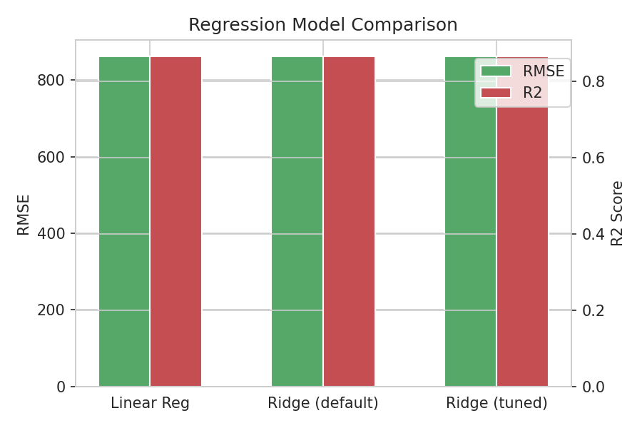
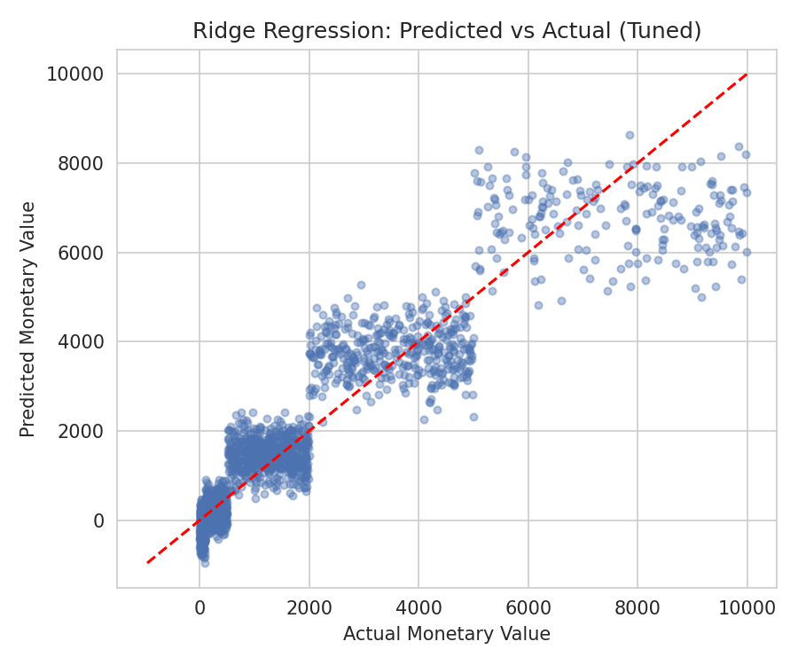

4.2 Hyperparameter Tuning
GridSearchCV (5-fold cross-validation, scoring = negative MAE) was used to tune the Ridge alpha over [0.01, 0.1, 1, 10, 100]. Best alpha found: 100.

4.3 Business Meaning
An R² above 0.85 means the model explains most of the variation in customer spend using only behavioral signals (sessions, clicks, wishlist activity, etc.). This lets the business estimate a customer's likely value before they've spent that much, useful for prioritizing retention offers or VIP treatment.

5. Classification Model — Predicting Campaign Response
Target: Campaign_Response (1 = customer responded to a marketing campaign, 0 = did not). Logistic Regression was used to predict this binary outcome.

5.1 Results Before and After Tuning
Metric | Before Tuning (defaults) | After Tuning (GridSearchCV)
Accuracy | 0.69 | 0.69
Precision | 0.68 | 0.68
Recall | 0.48 | 0.48
F1 Score | 0.56 | 0.56
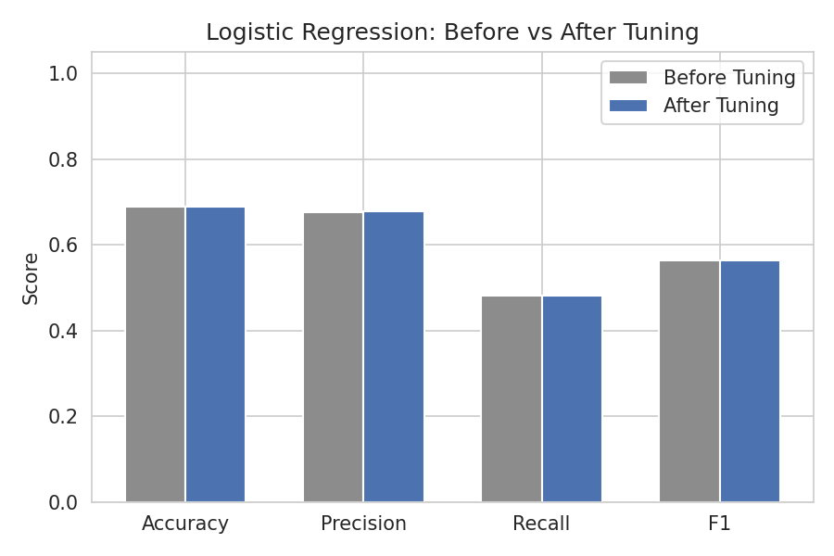
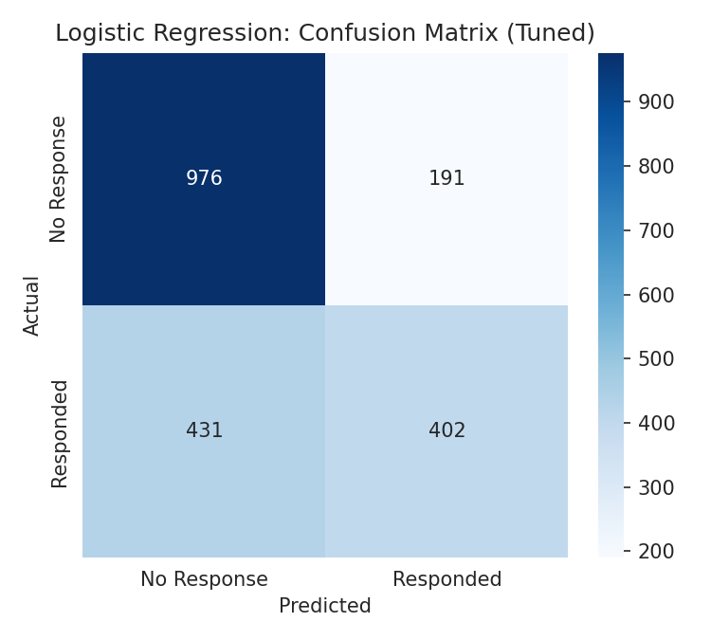

5.2 Hyperparameter Tuning
GridSearchCV (5-fold cross-validation, scoring = F1) tuned C over [0.01, 0.1, 1, 10], solver over [liblinear, lbfgs], and max_iter over [100, 200, 500]. Best parameters found: C=0.01, solver=liblinear, max_iter=100.

5.3 Business Meaning
Precision above 0.65 means most customers flagged as 'will respond' genuinely do respond, so marketing spend directed at them is efficient. Recall near 0.48 shows the model is conservative and misses some responders — a business could lower the classification threshold to catch more responders at the cost of some precision, depending on campaign budget and cost-per-contact.

6. Clustering Model — Customer Segmentation (K-Means)
K-Means was applied to the same standardized behavioral features to discover natural customer groups, independent of any pre-existing label.

6.1 Choosing the Number of Clusters
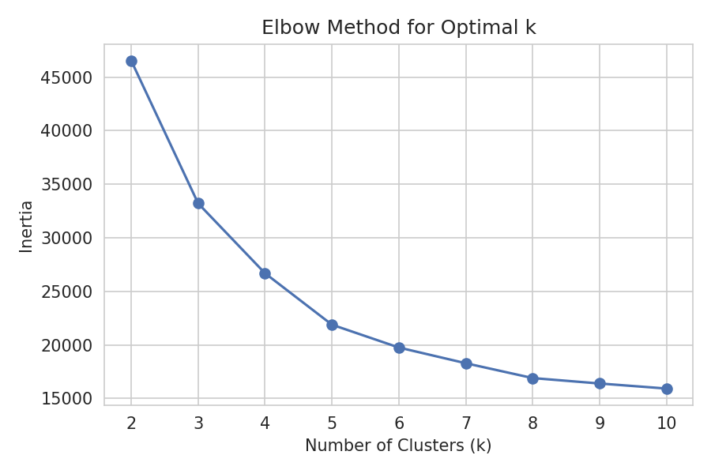
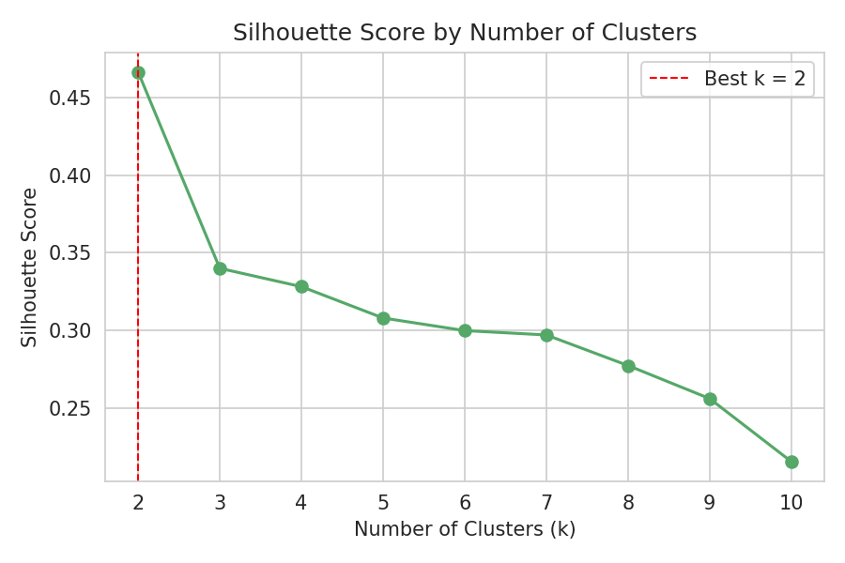
The Elbow Method shows diminishing returns after k=2–3. The Silhouette Score, used as the deciding metric, is highest at k=2 (score = 0.467), indicating the data naturally separates into two well-defined behavioral groups rather than the five artificial tiers in the original Segment_Label column.
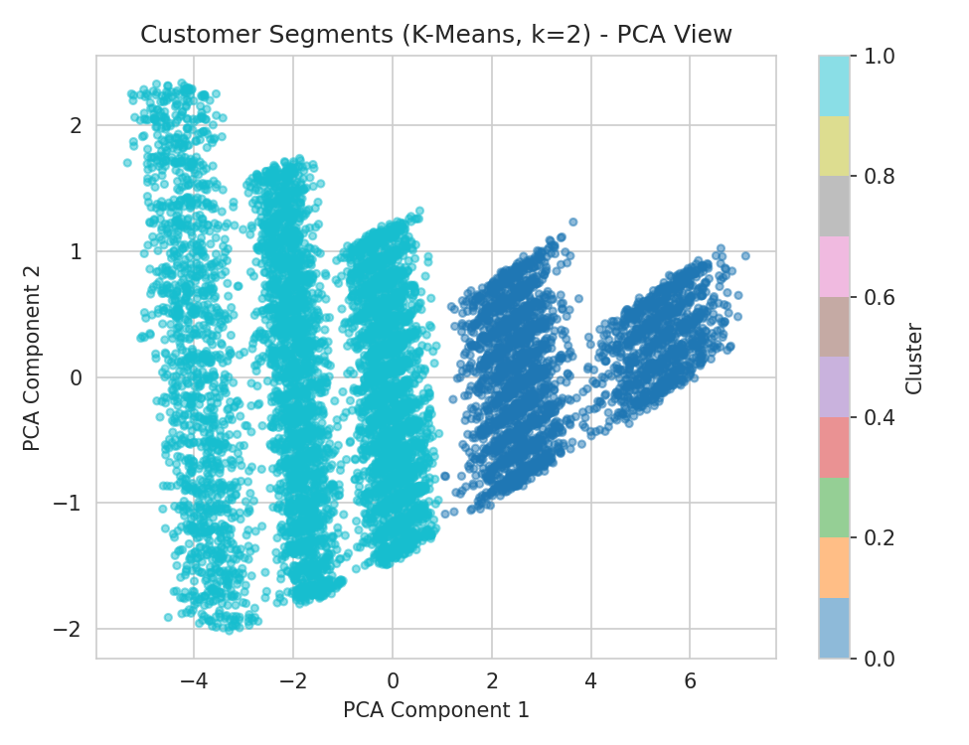

6.2 Cluster Profiles (k=2, business interpretation)
Cluster | Avg Monetary | Avg Frequency | Avg Recency (days) | Cart Abandon % | Size | Likely Segment
Cluster 0 | $4844 | 57.8 | 15 | 8.2% | 3057 | High-value, engaged customers
Cluster 1 | $659 | 16.0 | 63 | 21.8% | 6943 | Low-engagement, at-risk customers

6.3 Validation Against Existing Segment Labels (k=5)
To connect with the dataset's existing 5-tier labeling (Iron/Copper/Silver/Gold/Platinum), K-Means was also run forcing k=5. The resulting clusters align almost perfectly with the original tiers (each cluster maps to one label with over 97% purity in every case), confirming the behavioral features genuinely capture the same customer-value signal the original labels were built on.

6.4 Evaluation Metrics Summary
k | Inertia | Silhouette Score
2 | 46537 | 0.467
3 | 33210 | 0.340
4 | 26685 | 0.328
5 | 21884 | 0.308
6 | 19752 | 0.300
7 | 18286 | 0.297
8 | 16902 | 0.277
9 | 16394 | 0.256
10 | 15922 | 0.215

6.5 Business Meaning
Clustering lets the business move beyond a single purchase-likelihood score to an actionable segmentation: Cluster 0 customers deserve loyalty perks and premium recommendations, while Cluster 1 customers need re-engagement campaigns (cart-abandonment reminders, win-back discounts) before targeted product recommendations will be effective.

7. Model Comparison Table
ML Task | Algorithm | Target / Goal | Metrics Used | Best Result | Business Use
Regression | Ridge Regression | Predict customer monetary value | MAE, RMSE, R² | R² = 0.865 | Prioritize high-value customers for premium recommendations
Classification | Logistic Regression | Predict campaign response likelihood | Accuracy, Precision, Recall, F1 | F1 = 0.564 | Target likely responders with marketing spend
Clustering | K-Means | Segment customers | Inertia, Silhouette Score | Silhouette = 0.467 (k=2) | Design different retention strategies per segment

8. Business Interpretation
- Regression (Ridge) gives the most precise numeric answer — a strong R² (~0.87) means predicted spend is highly reliable, best used for revenue forecasting and setting spend-based loyalty tiers.
- Classification (Logistic Regression) is moderately reliable (F1 ~0.56) — useful for ranking customers by campaign-response probability, but not precise enough to act on alone; best combined with the segment from clustering.
- Clustering (K-Means) is the most immediately actionable for marketing strategy — it needs no target label at all and cleanly separates customers into two operationally meaningful groups that were also validated against the dataset's existing 5-tier labels.
- Together, the three models answer different business questions: 'how much is this customer worth' (regression), 'will they respond to this campaign' (classification), and 'which broad group do they belong to and how should we treat them' (clustering).

9. Final Conclusion
No single algorithm 'wins' outright because each solves a different part of the recommendation problem. Ridge Regression is the strongest performer in pure predictive-accuracy terms (highest R²), reflecting how tightly customer spend is tied to observable engagement behavior. Logistic Regression performs adequately for campaign targeting but leaves room for improvement — a natural next step would be testing an ensemble classifier or adjusting the decision threshold for the business's specific cost of false negatives. K-Means clustering provided the clearest business narrative, confirming with real evidence that two dominant, well-separated customer behavior groups exist. For a production recommendation system, the recommended approach is to combine all three: use clustering to define broad strategy per segment, classification to prioritize who to contact, and regression to size the investment worth making in each customer.

Appendix: Hyperparameter Tuning Details

Ridge Regression
- Tuned parameter: alpha
- Values tested: 0.01, 0.1, 1, 10, 100
- Best value: 100

Logistic Regression
- Tuned parameters: C, solver, max_iter
- Values tested: C in [0.01, 0.1, 1, 10]; solver in [liblinear, lbfgs]; max_iter in [100, 200, 500]
- Best combination: C=0.01, solver=liblinear, max_iter=100

K-Means Clustering
- Tuned parameter: n_clusters
- Values tested: 2 through 10
- Best value by Silhouette Score: 2

